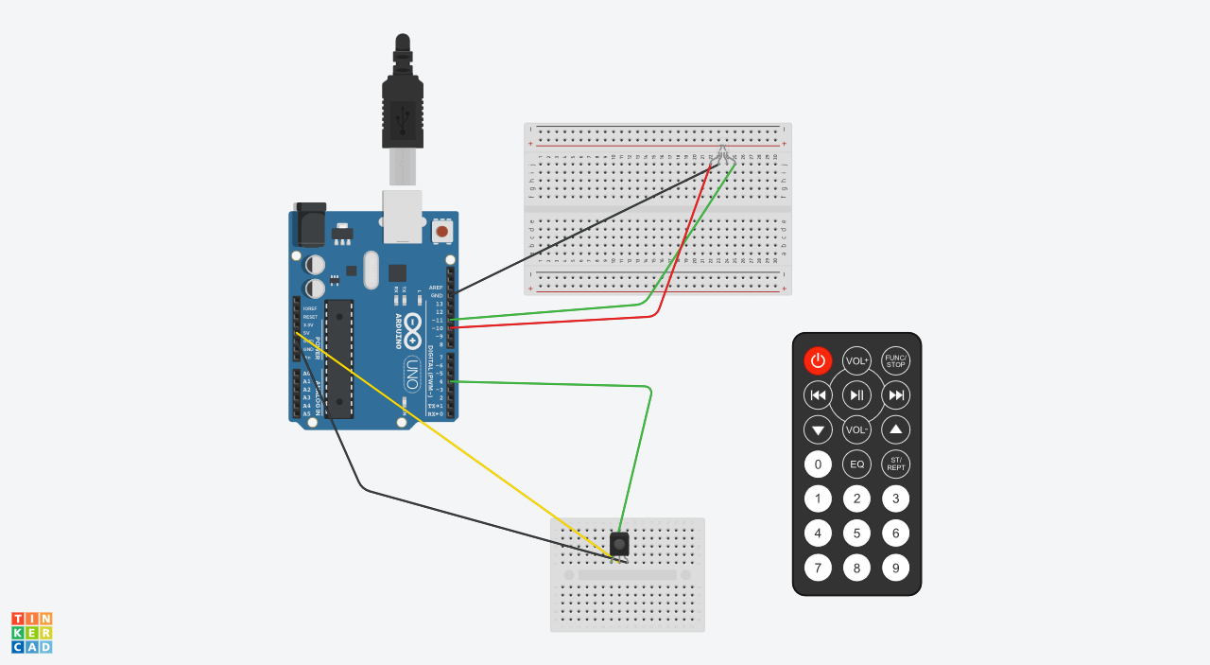
Arduino Traffic Lights

This is instead of
the apple tv remote.

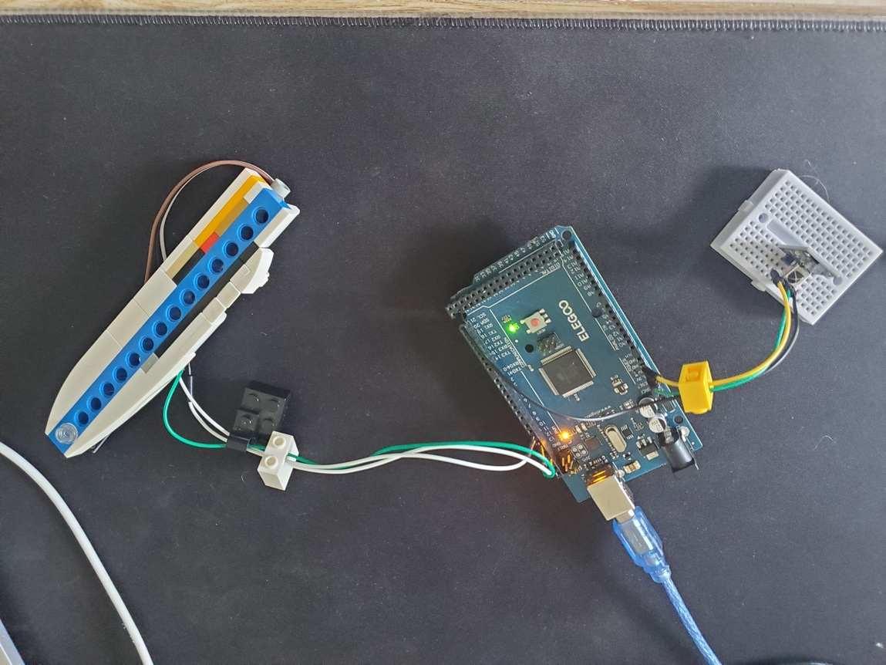
Fig 1: This is the wiring diagram. When connecting to the LED, only the red and green and
GND was plugged in and that was via a wire extension cable. (see fig 2)

Fig 2: This is the working prototype, with the led implemented into the Lego
module. The IR receiver is on a separate breadboard for easier access. All of
the wires are going through axle holes through 1x2 Lego bricks for incorporating
in Lego builds.

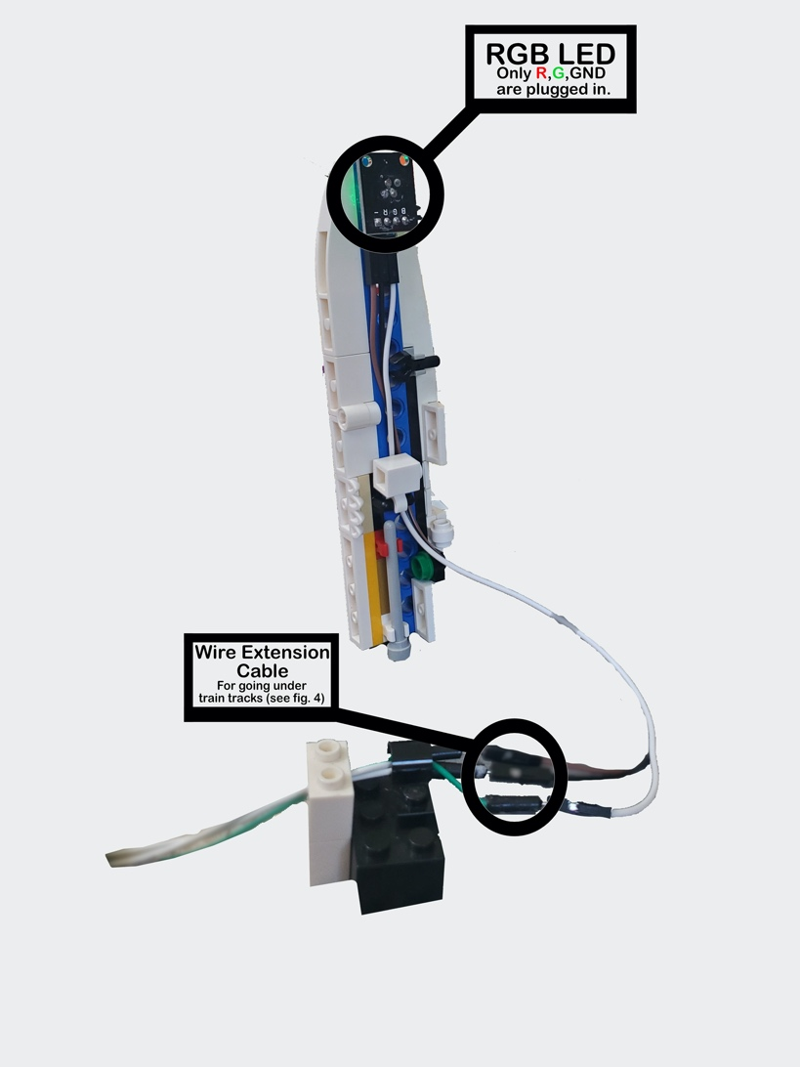

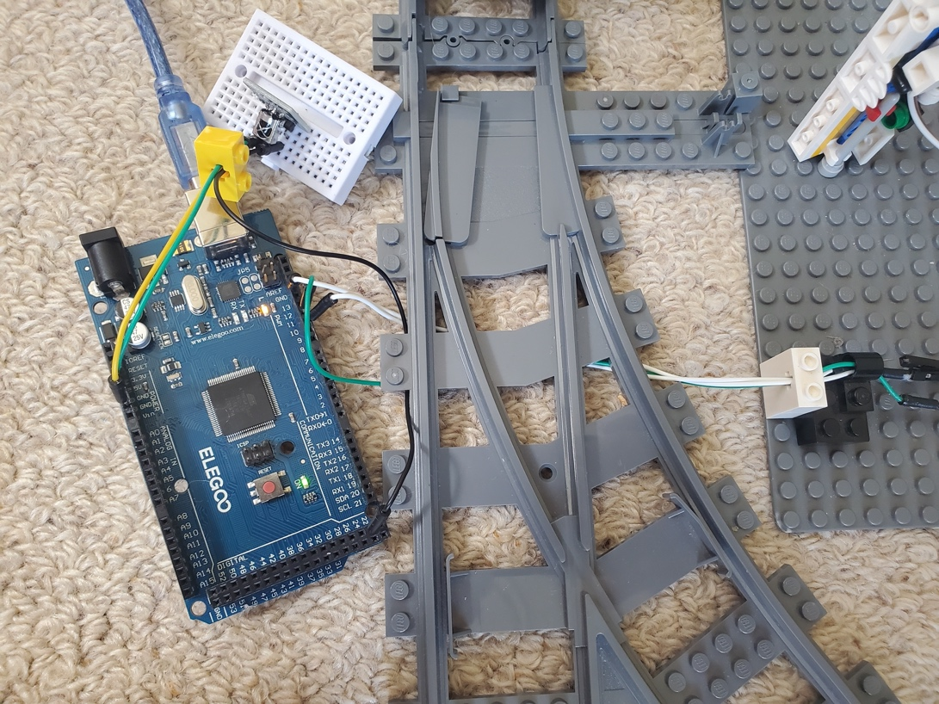

Fig 3: This is the back view of the module. Fig 4: This is the top view of the Arduino Mega module with wires going underneath the train tracks to the RGB LED.

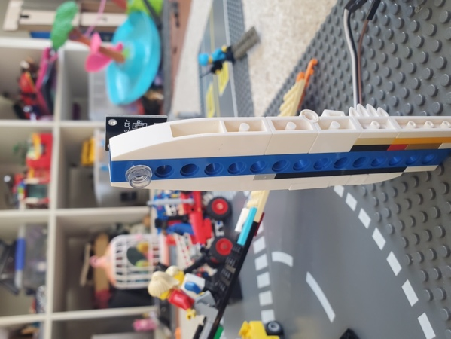
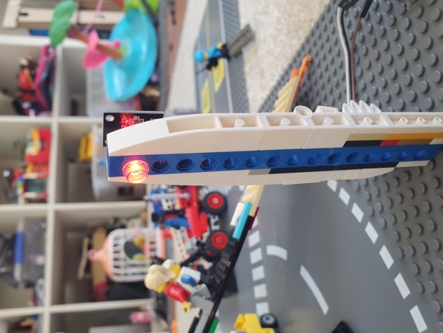
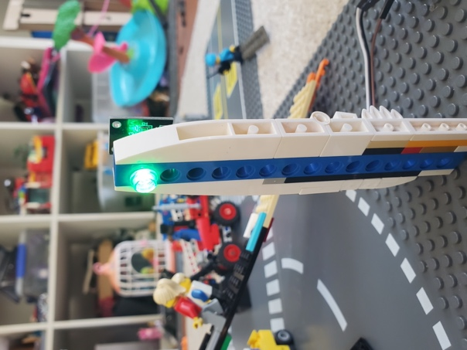

Fig 5: LED off. Fig 6: LED on green. Fig 7: LED on red

1. /*
2. * CombinedReceiver.cpp
3. *
4. * Demonstrates receiving NEC protocol IR codes with IRremote and controlling LEDs based on
5. * specific Apple protocol commands.
6. * This file is part of Arduino-IRremote https://github.com/Arduino-IRremote/Arduino-IRremote.
7. */
8.
9. #include <Arduino.h>
10. #include <IRremote.hpp> // Include the library
11.
12. // Define IR_RECEIVE_PIN to correspond with Digital Pin 22
13. #define IR_RECEIVE_PIN 22
14.
15. int RED = 10; // Define pin for red LED
16. int GREEN = 11; // Define pin for green LED
17.
18. void setup() {
19. Serial.begin(115200);
20.
21. // Notification on startup
22. Serial.println(F("START " __FILE__ " from " __DATE__ "\r\nUsing library version " VERSION_IRREMOTE));
23.
24. // Start the IR receiver
25. IrReceiver.begin(IR_RECEIVE_PIN, ENABLE_LED_FEEDBACK);
26.
27. Serial.print(F("Ready to receive IR signals of protocols: "));
28. printActiveIRProtocols(&Serial);
29. Serial.print(F(" at pin "));
30. Serial.println(String(IR_RECEIVE_PIN));
31.
32. // Setup LED pins
33. pinMode(RED, OUTPUT);
34. pinMode(GREEN, OUTPUT);
35. }
36.
37. void loop() {
38. if (IrReceiver.decode()) {
39. // Print a summary of received data
40. if (IrReceiver.decodedIRData.protocol == UNKNOWN) {
41. Serial.println(F("Received noise or unknown protocol"));
42. IrReceiver.printIRResultRawFormatted(&Serial, true);
43. IrReceiver.resume();
44. } else {
45. IrReceiver.resume(); // Enable receiving of the next IR frame
46. IrReceiver.printIRResultShort(&Serial);
47. IrReceiver.printIRSendUsage(&Serial);
48. Serial.println();
49.
50. // Check received data and perform actions
51. if (IrReceiver.decodedIRData.flags & IRDATA_FLAGS_IS_REPEAT) {
52. Serial.println(F("Repeat received. Here you can repeat the same action as before."));
53. } else {
54. handleIRCommands(); // Call function without parameters
55. }
56. }
57. }
58. }
59.
60. void handleIRCommands() {
61. // Check for the specific commands from the Apple protocol
62. if (IrReceiver.decodedIRData.protocol == APPLE) {
63. if (IrReceiver.decodedIRData.address == 0xF5 && IrReceiver.decodedIRData.command == 0xB) {
64. Serial.println(F("Received Apple command 0xB with address 0xF5."));
65. red_light(); // Turn on the red LED
66. } else if (IrReceiver.decodedIRData.address == 0xF5 && IrReceiver.decodedIRData.command == 0xD) {
67. Serial.println(F("Received Apple command 0xD with address 0xF5."));
68. green_light(); // Turn on the green LED
69. }
70. }
71. }
72.
73. void red_light() { // A function for turning only the red LED on
74. digitalWrite(GREEN, LOW); // Turning off the green LED
75. digitalWrite(RED, HIGH); // Turning on the red LED
76. }
77.
78. void green_light() { // A function for turning only the green LED on
79. digitalWrite(GREEN, HIGH); // Turning on the green LED
80. digitalWrite(RED, LOW); // Turning off the red LED
81. }
82.
83. void yellow_light() { // A function for turning both LEDs on (if needed)
84. digitalWrite(GREEN, HIGH); // Turning on the green LED
85. digitalWrite(RED, HIGH); // Turning on the red LED
86. }

